SPARK: Simple Play Adaptations to Reference for Kids

Pouring Cup on Flex Stand
Description: | Image:
The Pouring Cup is a switch-enabled measuring cup mounted on a flexible gooseneck stand that provides opportunities for children with physical disabilities to participate in everyday activities such as cooking, watering plants, pouring glitter on an art project, or filling a pet's watering dish. When you activate the first switch, the cup will pour liquids, sand, or flour into any container. Activating the second switch returns the cup to an upright position. The measuring cup is removable for easy cleaning. It is 27″L x 4″W x 3″H and weighs 3¼ lbs including the flex stand mount. 4 AA batteries are needed. The manufacturer recommends not using rechargeable batteries because they supply lower voltage and the unit may not perform as well.  Users Manual | 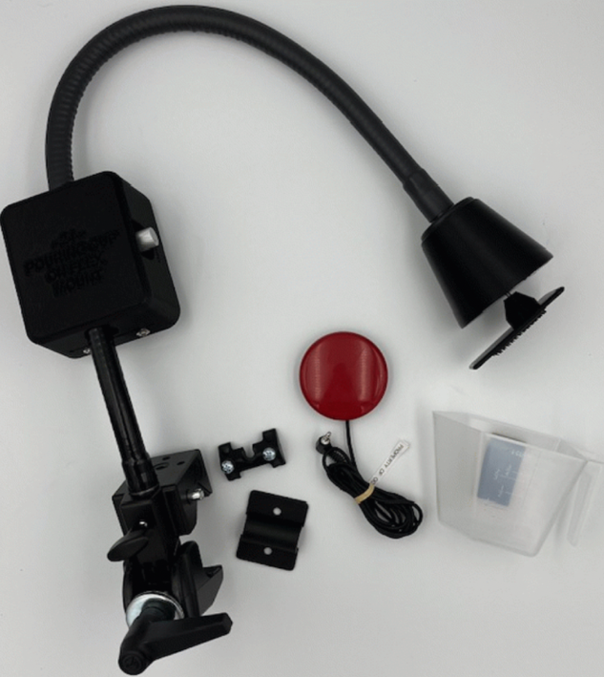  Purchasing Information  Demo Video

Who Might Benefit?
Those who need physical assistance to …
• Engage in activities of daily living such as cooking.
• Participate in simple science activities.
• Participate in art activities.
• Interact in pre-academic and academic activities.

Why Use?
Provides an opportunity to…
• Engage in elements of cooking activities.
• Participate in elements of simple science activities.
• Interact in elements of art activities.
• Participate in elements of pre-academic and academic activities.
Instructions for Use: | Adaptation Ideas:
Environmental Considerations  - Use on a table, counter, or wheelchair tray/frame where the gooseneck mount can be securely clamped to stabilize the cup.  Positioning  - Use with the child seated or on the floor with the child in various positions as long as there is a surface to clamp the gooseneck stand onto.  Basic Play/Use  Securing and Activating the Measuring Cup:  - Connect the unit to two switches via the jacks on the back of the plastic housing unit, behind the battery compartment. The Pouring Cup on Flex Mount is equipped with 1/8-inch switch jacks. Make sure that you have tight connections between the switches and the jacks. There should be NO GAPS.  - On the housing unit opposite the battery case is a speed adjustment knob, turning it clockwise increases the speed at which the cup turns and turning it counter clockwise decreases the speed.  - The measuring cup is attached to its mounting plate via dual lock Velcro and should be removed from the unit for cleaning. Do not clean it in the dishwasher.  - To attach the cup to the bell-shaped housing, first remove the pouring cup from the black mounting plate, by holding the black mounting plate with one hand and prying the cup off with the other hand.  - Next press the black mounting plate onto the metal shaft gently, leaving approximately ¼" of the shaft visible. Then secure the cup to the mounting plate by pressing the cup from the inside over the Velcro. Please note: the end on the vinyl nut will have a rough finish this is normal and not broken.  - Activate the first switch and the cup will pour. Activate the second switch to return the cup to the upright position. The Pouring Cup on Flex Mount attaches easily to flat surfaces, bars, or table legs.  Securing the Measuring Cup Mounting System to a Flat Surface or Tube:  - The mounting clamp is designed to mount to tubular (wheelchair, bedrail, walker, etc.) or flat surfaces such as a tabletop or desk.  - For flat surface mounting use the included wedge insert shoe stored in front of the locking knob on the clamp. Loosen the locking knob slightly to remove the wedge and tighten the knob once the wedge has been removed.  - Attach the pouring cup mounting to a wheelchair, table, or desk. Tighten the clamp enough to hold the pouring cup securely, but do not over-tighten.  - For some mounting applications the clamp will need to be mounted horizontally, a gooseneck clamp mount adapter is included for this use. To use the adapter, you first must remove the Gooseneck from the clamp, do this by loosening the set knob on the back of the clamp. This is the same knob that holds the clamp wedge. Next, depress the spring-loaded pin on the side of the clamp and pull the Gooseneck from the clamp. Attach the adapter to the Gooseneck and secure it with the included mounting screws.  Extended Play/Use  - Cooking: Use during class cooking activities so the student can add a liquid or dry ingredient to the recipe.  - Science: Mix ingredients to make silly putty or dough.  - Art: Pour paint onto a paint spinner, pour and mix colors to learn about primary and secondary colors, and pour glitter onto an art project.  - Math: Pour dice for probability activities, board games, or counting.  - Gardening: Pour dirt into a pot to plant seeds, or fill the cup with water to water plants.  - Literacy: Use as a rain prop for literacy activities for books such as Cloudy with a Chance of Meatballs, Mrs. Wishy Washy, and The Itsy Bitsy Spider.  Play/Use with Others  - Generally, requires at least two people to be engaged in the activity. One person loads the cup, and the other activates the switches to make the cup pour the liquid or solid. The other person could be an adult or a peer. | Optional Additional Materials/Supplies  - Velcro  - Non-skid matting (Dycem or cabinet liner)  Stabilize It  - Stabilize switches on the table with either Velcro or a non-skid matting such as Dycem.  Add Sensory Cues  - Add textures, colors, or picture symbols combined with words to the switches to assist the child who needs more information either about the function of the switch or encouragement to engage with the switch.  Communication Support  - Communication boards could be developed with keywords needed to engage in the specific activity the pouring cup is being used to support (cooking, art, math, literacy, gardening, etc.)  Alternative Uses  - Different types of switches could be trialed if the included switch is not usable by the child. The OCALI lending library has several kits with multiple types of switches that can be trialed.

Additional Considerations:
- The switches provided work with the switch ports in the device. If you choose to use other switches and a 1/4- to 1/8-inch adapter is required, they must be mono adapters, not stereo.
Resources:
- 25 Things to Do with a Switch Activated Pouring Cup - Kate Ahern
https://teachinglearnerswithmultipleneeds.blogspot.com/2010/04/25-things-to-do-with-switch-activated.html
- Using a Switch Activated Pouring Cup to stack cups for color pattern matching
https://www.instagram.com/adapt.include.move/reel/DAhWp9Nvkes/
Ohio Early Learning Standards:
- SC: Science Inquiry and Application: Develops ability to reason about cause and effect. (1.b.)
- Because this is an access tool this may support multiple areas of the Ohio Early Learning Standards depending upon the paired activities with the device.

Words to Encourage Play/Use
Go  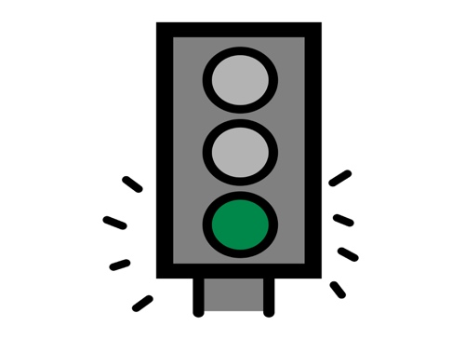 | Stop   | Pour 
Done | More 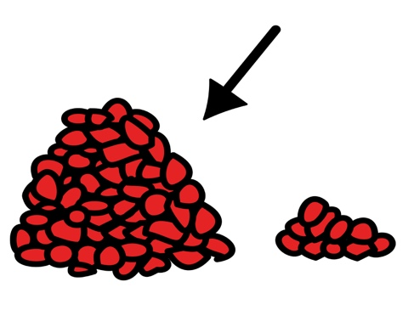 | In  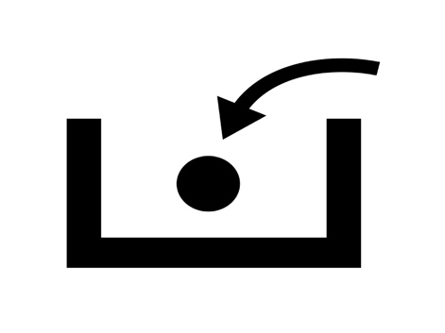
My Turn | Your Turn   | Help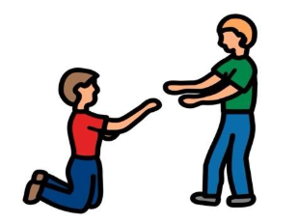
*”Adaptations” adapted from: Haugen’s Modes for Adapting Toys based on materials from the "Let's Play" Project at the University of Buffalo
PCS is a trademark of Tobii Dynavox, LLC. All rights reserved. Used with permission.

